
Why Do We Exist?

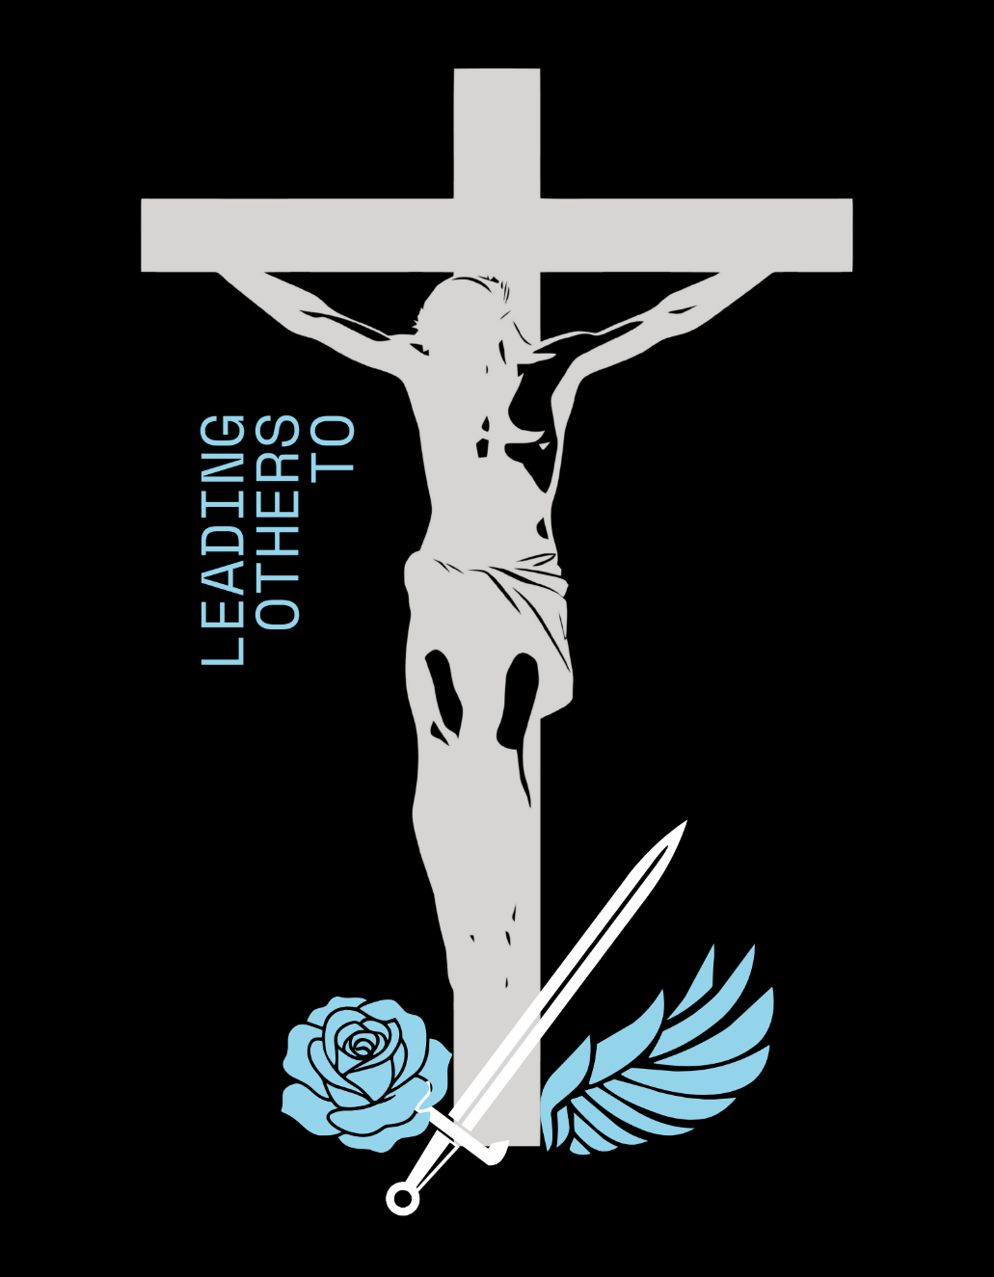
How Do We Behave?
How Will We Succeed?

Joyful Family Spirit

We cultivate a culture of communion among our Carroll students, families, and staff, by developing relationships founded on Christ and vulnerability-based trust.
Communicating Conversion

We provide opportunities for our Carroll family to hear about conversion and to communicate their own conversion.
Motivating Mission

We equip our Carroll family to recognize and embrace their unique charisms and their mission in building the Kingdom of God.

What Do We Do?

In the spirit of Mother Luisita,
we draw the Carroll family
into an encounter with
the Sacred Heart of Jesus through evangelization, formation, and worship.


What Is Most Important,
RIGHT NOW?

- Assess the Ministry.
- Discern the Systems.
- Build a Cohesive
Leadership Team.

